# 2021_01_11

* **What is OTP for? I think it should be removed.-> done**
* **Change Item description to location description -> done**
* **Put choose file after the description -> done**
* Make the screen narrower
  + ->which screen you want to narrow down please attach screenshot for reference. – The screen that displays the items or put all four columns in one line 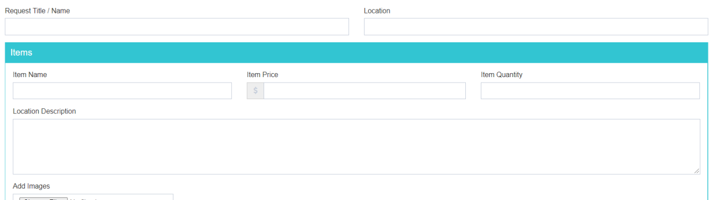
* Allow to edit item in the list.-> **done**
* **Remove Captcha from the form used to add items -> done**
* **Display the dollar amount with currency formatting -> done**
* **Keep the added list less height ->** [**http://prntscr.com/wlsg6e**](http://prntscr.com/wlsg6e) **-> done**
* Make two terms & conditions sections on the page with a check box for the user to check of and confirm they read it. For now you can fil it with Lorem Ipsum
  + -> how we can two terms and conditions . Like this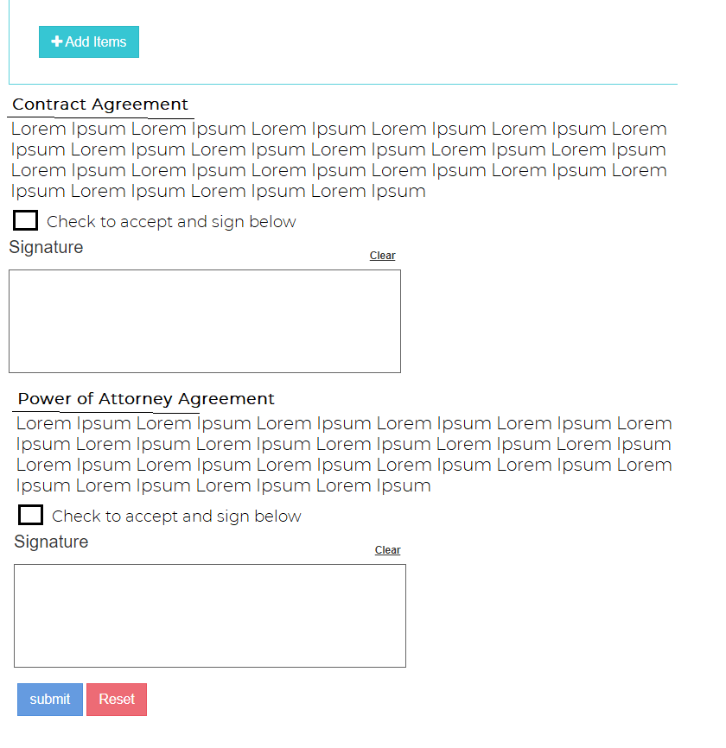
* Each section will need a signature and check box
  + -> are you refraining that user terms and conditions section or something else please describe. => Working See image above
* Where can I create an order based off of a previous order? I should be able to copy a previous order, modify it ay editing, deleting and adding items. => **Pending**
* The **admin** user should be able to print the order.
  + Each terms & conditions is a different document to be printed.
  + The way it should print is as follows.
    - For the first terms & conditions section print the name and location and the text of the terms & conditions. Then print the items that were sold on the next page. Each page should have the signature.
    - For the second terms & conditions print the terms & conditions on the first page. The next page should print all the signatures from all the Processed orders
  + I will give the header and exact language for the terms & conditions -> **Send me this INformation**

-> need more description on how the whole terms and condition feature work. Since each terms & conditions is a different agreement there needs to be two different documents. The items that are listed should be part of only one of the terms and conditions. The first page will display the contract which includes the name and location. The second page will have the items listed. Each one need to have the signature on it.

The second terms & condition is the power of attorney. It is enough to print the power of attorney and all the signatures from all sales can be printed on a separate page.

Here is an image: 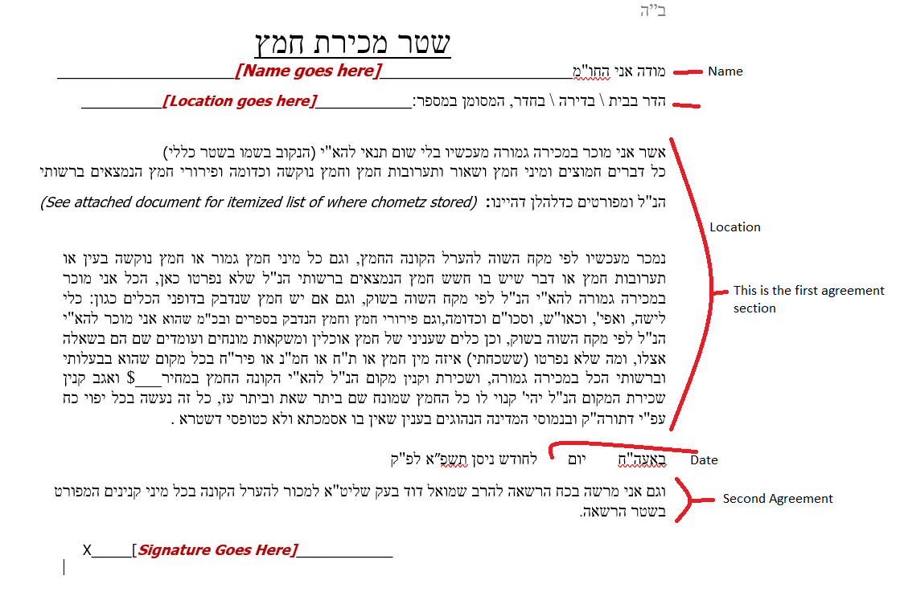

* **I could not change the status of an order -> done**

# 2021_16_02

1. How can I add multiple locations?
2. Add cell phone field to the form.

# 2021_03_01

1. ~~Remove the limit on the location.~~ 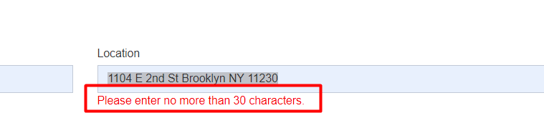
2. ~~When I press Add Item I get this message~~. 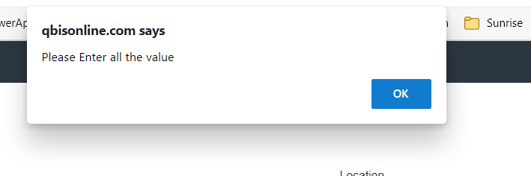
3. ~~There is an extra signature box.~~
4. ~~The user should be able to download and print the contracts with the items added~~
5. The list is displaying doubles. 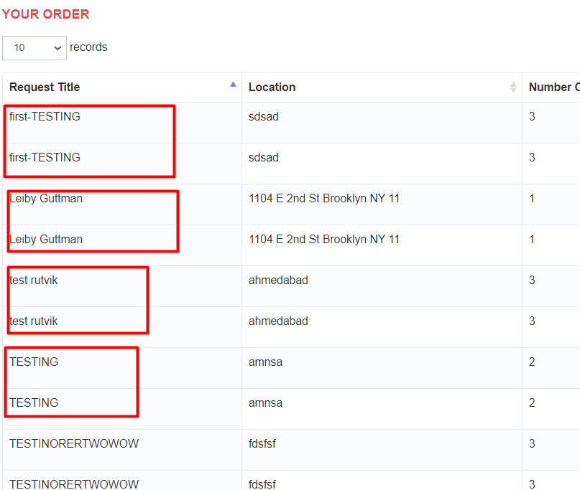
6. 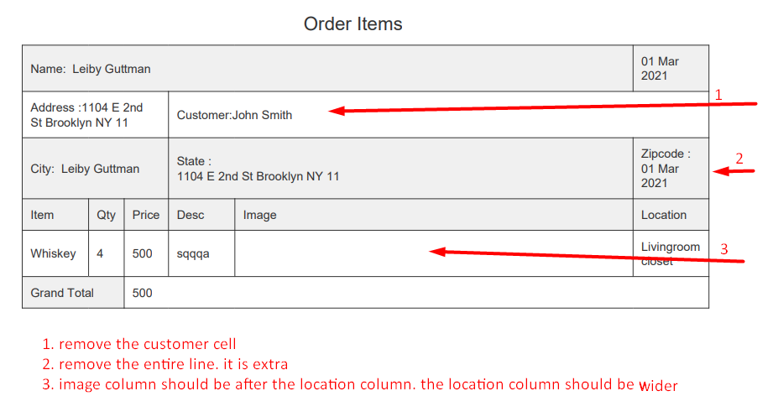
7. The first page does not have the proper setup as described.
8. Remove the location Description 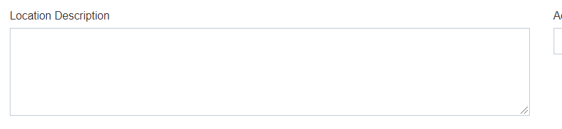
9. ~~Got this error when trying to create a new account~~ 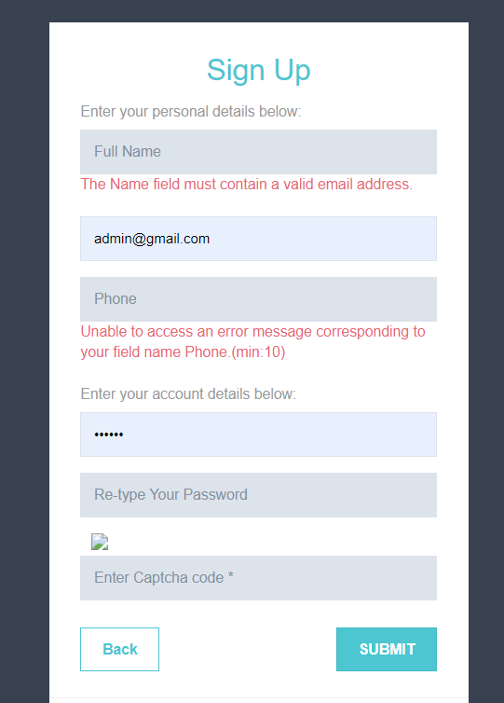

# 2021_03_02

1. ~~The list is displaying doubles. It happens when you view the detail and then hit the back button. It only happened with the username~~ [~~admin@gmail.com~~](mailto:admin@gmail.com)~~.~~ 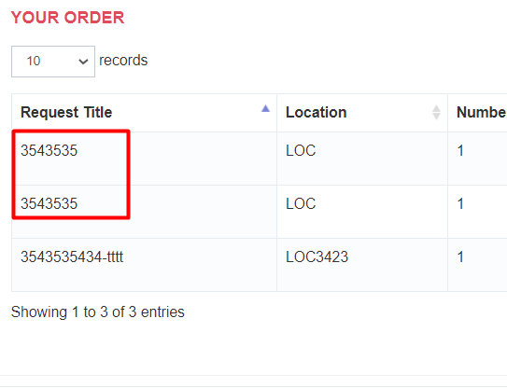
2. ~~Nothing happens when you click on the image. The image is too small to view in the cell.~~
3. ~~Remove the location Description~~ 
4. The first printed page does not have the proper setup as described. The signatures are blank.
5. ~~There should be a signature on the items list too.~~
6. There are too many pages for me to figure out which section and signature go to what.
7. Add descriptions to the icons when hovering with the mouse.
8. ~~Remove the dashboard tab~~ 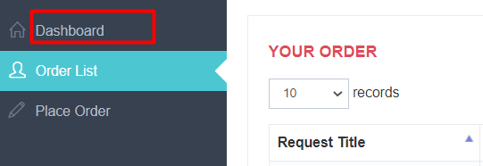
9. ~~Add cell phone field to the form.~~ 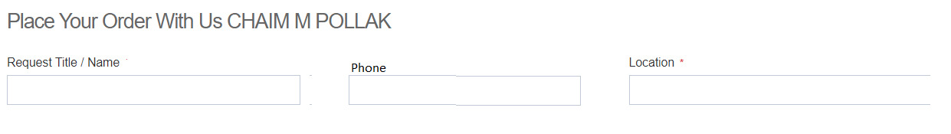
10. ~~Change Location to Address~~
11. ~~Change Request Title to Full Name. It should be set automatically based on the login name.~~
12. ~~Change the title from" Place your order with us" and the name to "Mechiras Chometz"~~
13. I think only one signature box is enough, as long as they appear in the places on the printed form.
14. Add a filter for statuses

# 2021_03_03

1. Allow the name to be editable.->done
2. Change the label to Mechiras Chometz. ->done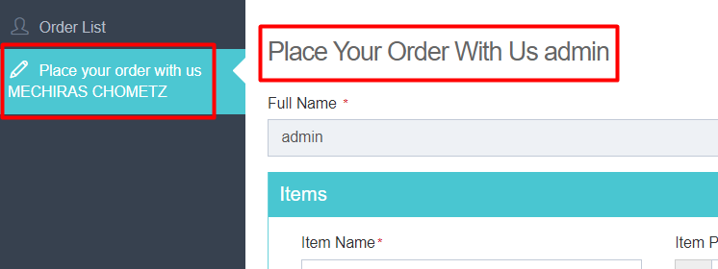
3. The first printed page does not have the proper setup as described. The signatures are blank.
4. There should be a signature on all the items list pages too.
5. There are too many pages for me to figure out which section and signature go to what.
6. Add descriptions to the icons when hovering with the mouse.->done
7. I think only one signature box is enough, as long as they appear in the proper places on the printed form.
8. Add a filter for statuses to the admin's main screen.
9. Is the database getting cleaned up every day? I don't see yesterday's records.->done
10. The admin needs to print the power of attorney section with all the signatures on it. It should have all the signatures that have a status of Pending on the list.
11. We need to add the Hebrew text to the printed page.done
12. When the user logs in, they should see the order list page, not this page. ->done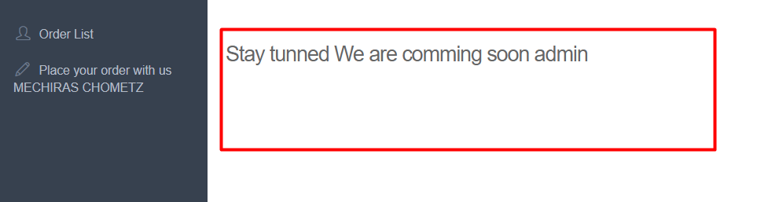
13. The admin should be able to turn on or off the Agreement and signing features. By default, it should b turned off for all new users.
14. As long as an order's status is New, I should add and edit items on the list.
15. When clicking on the copy icon on the main page, the back button does not display on the detail page. 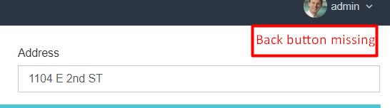
16. The copy button should only save the copy if Submit is pressed on the detail page. Just pressing copy should not create and save a new order.
17. Remove the Captcha when creating a new account.
18. Add a filter for the year to search orders by the year.
19. Add the phone to the printed page with the items listed on it.
20. For each item Name, there should be a sorted dropdown for the user to choose an item. The dropdown should have an option to choose "Other" with the ability to type in other names that are not in the dropdown.->done append issue pending
    1. **Entire Location (This should be the first option)**
    2. Barley
    3. Beer
    4. Cake
    5. Cereal
    6. Cosmetics
    7. Flour
    8. Ketchup
    9. Mayonnaise
    10. Medicine
    11. Mustard
    12. Oatmeal
    13. Office
    14. Other
    15. Other Home
    16. Pasta
    17. Play Dough
    18. Salad
    19. Sauces
    20. Soup Mixes
    21. Vinegar
    22. Vitamins
    23. Whiskey
    24. Yeast
    25. Other
21. Why did it print this here? 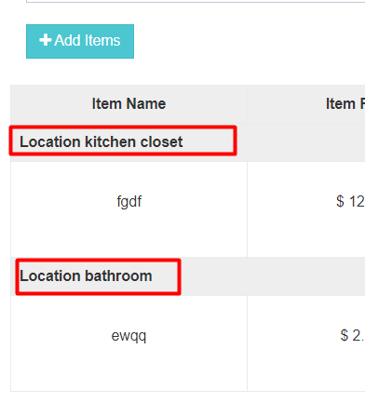
22. got "Please enter atleast One Item"  should say got "Please enter at least one item". There should be a space between the word at and least.
23. This is what I meant by multiple locations with their own list of items. 